The decisions we have to make are not always easy and often not black or white!

Where do you go for guidance when you’re not sure what to do?

Joseph took Mary to be his wife and brought Jesus up as his own. Are there people who need our care/protection that we could ‘adopt’ into our families?



The Annunciation

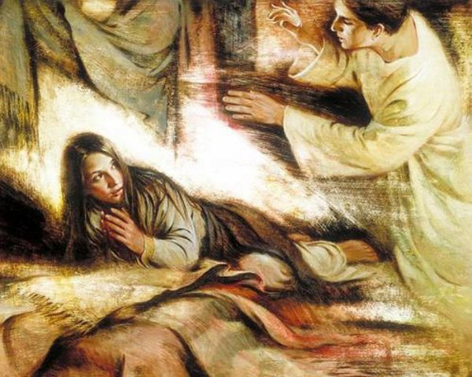

Luke 1:26-38 Matthew 1:18-25

‘Greetings highly favoured one! The LORD is with you.’

Imagine hearing these words spoken over you. Sit with them. How do they make you feel?

The angel said to both Mary and Joseph, ‘Do not be afraid.’ They both faced their fears by trusting in what God said.

Are you anxious or afraid of anything just now? What might God’s be saying to you to help you face your fears and overcome them?

How do you respond to the idea that the Holy Spirit wants to ‘form Christ in you?’

How might you give the Holy Spirit more access to ‘overshadow you?’

Joseph did not want to expose Mary to public disgrace.

Social media and careless words can quickly damage people’s reputations. What steps can you take to ensure you don’t become drawn into this kind of behaviour?